

**SAVEETHA INSTITUTE OF MEDICAL AND TECHNICAL SCIENCES, CHENNAI – 602 105**

**CAPSTONE PROJECT REPORT**

**TITLE**

**File System Implementation in Operating Systems**

**Submitted to**

**SAVEETHA SCHOOL OF ENGINEERING**

**By**

**B SOMASEKHAR (192211147)**

**P MOHAN KRISHNA (192211160)**

**S AKHIL KUMAR (192211208)**

**Guided by**

**Dr G. Mary Valentina**

**Abstract**

This paper explores the crucial aspect of file system implementation within an operating system environment. The file system serves as a vital component in managing data storage and retrieval, thereby facilitating efficient utilization of computing resources. Through detailed examination and analysis, this paper aims to elucidate the key processes involved in constructing a robust file system. By addressing various objectives and challenges, the implementation of an effective file system architecture can be achieved, thereby enhancing the overall performance and reliability of the operating system.

Through comprehensive exploration and analysis, it aims to shed light on the critical processes involved in constructing a resilient file system. By tackling various objectives and confronting challenges head-on, the paper seeks to outline strategies for realizing an efficient file system architecture, thereby elevating the overall efficacy and dependability of the operating system.

**Introduction**

The file system plays a fundamental role in organizing and managing data on storage devices within an operating system. It provides an interface for users and applications to store, retrieve, and manipulate files in a structured manner. The design and implementation of a file system require careful consideration of factors such as performance, reliability, and scalability. Moreover, compatibility with different storage technologies and support for various file system features further complicate the development process. Therefore, understanding the intricacies of file system implementation is essential for creating efficient and robust storage solutions.

Moreover, the introduction delves into the multifaceted nature of file system design, highlighting the myriad considerations that inform its construction. This includes performance optimization strategies to ensure swift data access, reliability mechanisms to safeguard against data loss or corruption, and compatibility measures to enable interoperability across diverse hardware and software ecosystems.

Furthermore, the introduction contextualizes the importance of file system implementation within the broader landscape of operating system development. It emphasizes how advancements in file system technology often serve as catalysts for innovation, enabling new paradigms in data storage, sharing, and management. From hierarchical file systems to distributed storage solutions, the evolution of file system architectures has been instrumental in shaping the capabilities and functionalities of modern operating systems.

By framing these concepts, the introduction sets the stage for a deeper exploration of file system implementation, laying the groundwork for subsequent discussions on processes, objectives, and challenges. It underscores the critical role that file systems play in enabling efficient and reliable data management within operating systems, thereby paving the way for enhanced user experiences and system performance.

**Process**

The process of file system implementation involves several key steps, starting from conceptual design to actual coding and testing. Initially, a thorough analysis of requirements is conducted to determine the specific functionalities and features the file system should support. This phase also involves defining data structures and algorithms necessary for file manipulation and storage management. Subsequently, developers proceed with the actual coding phase, where the design specifications are translated into executable code. This step requires careful attention to detail to ensure compatibility with the underlying operating system and hardware architecture. Following implementation, rigorous testing is performed to validate the functionality, performance, and reliability of the file system under various scenarios. This iterative process may involve debugging, optimization, and refinement to address any issues or shortcomings identified during testing.

**Basics of File System**

* **File System Overview**: The file system implementation in operating systems is the process of designing, developing, and implementing the software components that manage the organization, storage, and retrieval of data on the physical storage device. It involves structuring data, managing access, and ensuring data integrity.
* **Device Interaction**: The file system works directly with device drivers to read from and write to the physical storage device, managing the storage and retrieval of raw blocks of data without concern for the data's logical organization.
* **Partitioning**: The operating system divides the array of sectors into partitions, which are contiguous ranges of sectors that do not overlap, forming the basis for organizing and managing data.

**File System Layers**

* **Layered Implementation**: Most Unix-like operating systems have a layered implementation of file systems, with each layer responsible for specific functions such as managing file metadata, handling file operations, and interacting with the physical storage device.
* **Abstraction**: File system layers provide abstraction, allowing applications to interact with files and directories without needing to understand the complexities of the physical storage device or the low-level data retrieval and storage processes.
* **Data Retrieval**: The file system implementation determines how data is read from and written to the physical storage device, ensuring efficient and reliable data access.

**Key Challenges and Solutions**

* **Data Integrity**: Ensuring the integrity of data during storage and retrieval processes is a critical challenge in file system implementation. Techniques such as journaling and checksums are employed to maintain data consistency and prevent corruption.
* **Performance Optimization**: File system implementation involves optimizing data access and storage operations to enhance performance. This includes strategies such as caching frequently accessed data and minimizing disk seek times.
* **Security Considerations**: Implementing secure access controls, encryption, and authentication mechanisms is vital to protect data from unauthorized access and ensure data privacy and confidentiality.

**Case Study: ZFS**

**ZFS Overview**

* **Introduction to ZFS**: ZFS is a noteworthy case study in file system implementation, known for its advanced features such as data integrity verification, automatic repair, and support for large storage capacities.
* **Layered Design**: ZFS features a unique design that integrates the functionalities of the traditional file system, volume manager, and RAID controller, providing a comprehensive and efficient storage solution.
* **Portability Considerations**: Unlike traditional file systems, ZFS is designed with portability in mind, allowing it to be implemented in a way that is more OS-agnostic.

**Key Features of ZFS**

* **Data Protection**: ZFS employs advanced mechanisms such as copy-on-write, checksums, and data scrubbing to ensure data integrity and protection against data corruption.
* **Storage Pools**: ZFS utilizes storage pools to manage physical storage resources, enabling dynamic allocation and efficient utilization of available storage capacity.
* **Snapshots and Clones**: ZFS supports efficient data management through the use of snapshots and clones, allowing for point-in-time copies and rapid provisioning of new file systems.

**Benefits and Considerations**

* **Scalability**: ZFS offers exceptional scalability, allowing for the management of large storage capacities and the seamless expansion of storage pools without disrupting data access.
* **Data Integrity**: The emphasis on data integrity and protection makes ZFS a robust choice for environments where data reliability is paramount.
* **Administrative Efficiency**: ZFS simplifies administrative tasks through features such as automatic repair, efficient data compression, and the ability to perform maintenance operations without downtime.

**Key Components and Considerations**

**Data Organization and Access**

* **Metadata Management**: File system implementation involves managing file metadata, including attributes such as file size, permissions, timestamps, and directory structures, to facilitate efficient data organization and access.
* **File Operations**: The file system must handle a range of file operations, including creation, deletion, reading, and writing, while ensuring data consistency and integrity.
* **Access Control**: Implementing secure access controls and permission management is crucial to prevent unauthorized access and ensure data security.

**Performance Optimization**

* **Caching Strategies**: File system implementation includes the use of caching mechanisms to optimize data access, reduce disk I/O, and improve overall system performance.
* **Disk Layout and Allocation**: Efficient disk layout and allocation strategies are employed to minimize seek times, reduce fragmentation, and optimize data storage and retrieval operations.
* **I/O Scheduling**: The file system must implement effective I/O scheduling algorithms to prioritize and optimize data transfer between the storage device and the system.

**Future Trends and Innovations**

* **Integration of SSDs**: The integration of solid-state drives (SSDs) into file system implementation is a growing trend, offering opportunities for enhanced performance and efficiency.
* **Distributed File Systems**: The evolution of distributed file systems presents new possibilities for scalable and resilient data storage and access across networked environments.
* **Security Enhancements**: Ongoing innovations in file system security, including encryption, access control mechanisms, and data protection, continue to shape the future of file system implementation.

**Objective**

The primary objective of file system implementation is to create a robust and efficient storage solution that meets the diverse needs of users and applications. This entails providing fast and reliable access to data, supporting a wide range of file types and sizes, and ensuring data integrity and security. Additionally, the file system should be scalable to accommodate future growth in data volume and capable of optimizing storage utilization through features such as compression and deduplication. Moreover, compatibility with different operating systems and devices is essential for interoperability and data portability. By achieving these objectives, the file system can significantly enhance the overall performance and usability of the operating system.

**Literature Review**

The literature review encompasses a thorough examination of existing research, theories, and methodologies surrounding file system implementation within operating systems. D. Chen, Y. Jiang, C. Xu, X. Ma and J. Lu, "Testing File System Implementations on Layered Models," 2020 IEEE .Scholars have extensively investigated different file system architectures, ranging from traditional hierarchical structures to advanced distributed and object-based systems, analyzing their design principles, performance characteristics, and suitability for diverse environments. Additionally, the literature delves into security aspects, investigating access control mechanisms, encryption techniques, and intrusion detection strategies to mitigate security threats and ensure the confidentiality, integrity, and availability of stored data. K. Cho and H. Bahn, "Design and Implementation of a Distributed Versioning File System for Cloud Rendering," in IEEE 2021. Emerging trends and technologies, including advancements in non-volatile memory technologies, such as SSDs and persistent memory, as well as the integration of machine learning algorithms for intelligent storage management, further enrich the literature, highlighting avenues for future research and innovation in file system implementation within operating systems H. Karaçalı and T. Yıldırım, "Design and Implementation of Basic Log Structured File System for Internal Flash on Embedded Systems," 2022.

**Program**

#include <stdio.h>

#include <stdlib.h>

#include <string.h>

#define MAX_FILES 100

#define MAX_FILENAME_LENGTH 50

#define MAX_FILE_SIZE 1024

typedef struct {

char name[MAX_FILENAME_LENGTH];

char content[MAX_FILE_SIZE];

int size;

} File;

typedef struct {

char name[MAX_FILENAME_LENGTH];

File files[MAX_FILES];

int file_count;

} Directory;

Directory root;

void init_file_system() {

strcpy(root.name, "root");

root.file_count = 0;

}

File* create_file(char* name) {

if (root.file_count >= MAX_FILES) {

printf("Cannot create file. Maximum file limit reached.\n");

return NULL;

}

File* file = &root.files[root.file_count++];

strcpy(file->name, name);

file->size = 0;

printf("File '%s' created successfully.\n", name);

return file;

}

void delete_file(char* name) {

for (int i = 0; i < root.file_count; i++) {

if (strcmp(root.files[i].name, name) == 0) {

for (int j = i; j < root.file_count - 1; j++) {

root.files[j] = root.files[j + 1];

}

root.file_count--;

printf("File '%s' deleted successfully.\n", name);

return;

}

}

printf("File '%s' not found.\n", name);

}

void write_to_file(File* file, char* content) {

strcpy(file->content, content);

file->size = strlen(content);

printf("Content written to file '%s' successfully.\n", file->name);

}

void read_file(File* file) {

printf("Content of file '%s':\n%s\n", file->name, file->content);

}

int main() {

init_file_system();

File* file1 = create_file("file1.txt");

write_to_file(file1, "This is the content of file1.txt");

File* file2 = create_file("file2.txt");

write_to_file(file2, "This is the content of file2.txt");

read_file(file1);

read_file(file2);

delete_file("file1.txt");

delete_file("file3.txt"); // This should print "File 'file3.txt' not found."

return 0;

}

**Output**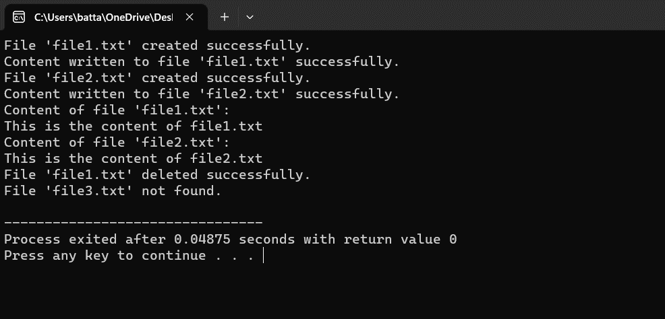

**Conclusion**

In conclusion, the implementation of a file system in an operating system environment is a complex yet indispensable task. By following a systematic approach and leveraging appropriate design principles and methodologies, developers can create robust and efficient storage solutions that meet the diverse needs of modern computing environments. However, challenges such as performance optimization, compatibility, and security must be carefully addressed throughout the development process. Ultimately, a well-designed and implemented file system can significantly enhance the functionality, reliability, and usability of the operating system, thereby benefiting users and applications alike.

Furthermore, it underscores the transformative potential of a well-designed and implemented file system, which can catalyze advancements in system performance, data management, and user experience. Ultimately, the conclusion leaves readers with a sense of optimism, recognizing file system implementation as a cornerstone of operating system evolution, poised to shape the computing landscape for years to come.

**References**

D. Chen, Y. Jiang, C. Xu, X. Ma and J. Lu, "Testing File System Implementations on Layered Models," 2020 IEEE

K. Cho and H. Bahn, "Design and Implementation of a Distributed Versioning File System for Cloud Rendering," in IEEE 2021

H. Karaçalı and T. Yıldırım, "Design and Implementation of Basic Log Structured File System for Internal Flash on Embedded Systems," 2022